ML assignment2 (PRAKHAR SAXENA [prakharsaxena303@gmail.com](mailto:prakharsaxena303@gmail.com)

7292024671)

OUTPUT(observations)

def __init__(self):

super(Net, self).__init__()

self.fc1 = nn.Linear(28 * 28, 200)

self.fc2 = nn.Linear(200, 10)

self.fc3 = nn.Linear(200, 10)

def forward(self, x):

x = F.relu(self.fc1(x))

x = F.relu(self.fc2(x))

x = self.fc3(x)

return F.log_softmax(x)

net = Net()

print(net)

**optimizer = optim.SGD(net.parameters(), lr=learning_rate, momentum=0.9)**

criterion = nn.NLLLoss()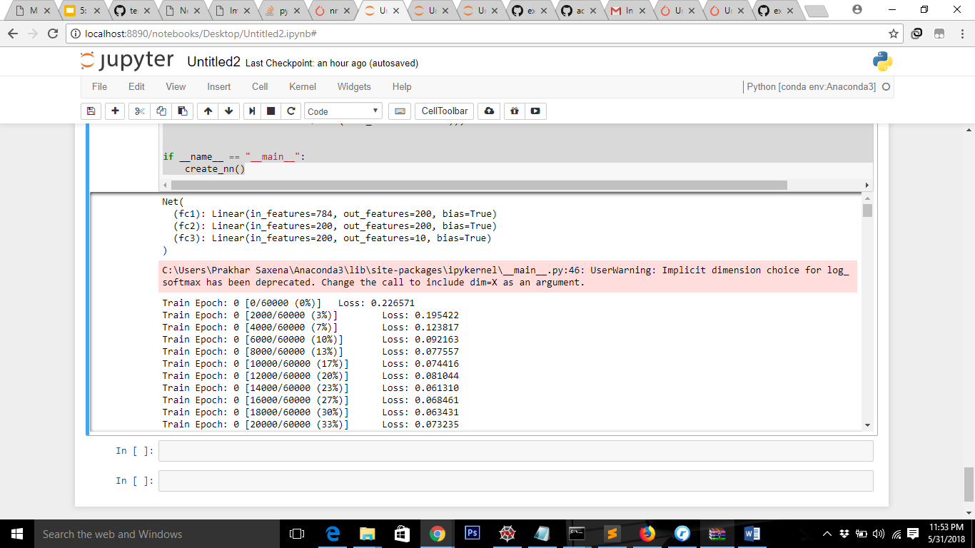

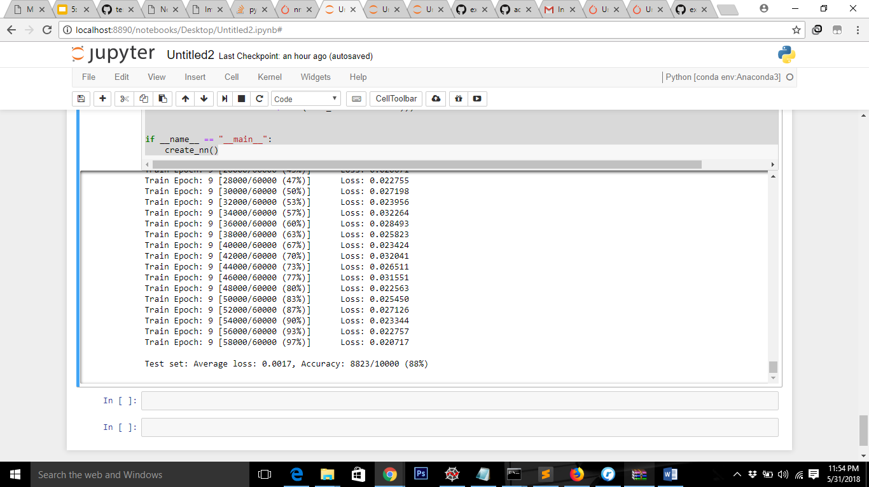

Accuracy = 88 %

‘

**Using optimiser ADAM AdaGrad Momentum**

“”optimizer = optim.Adam(net.parameters(), lr=learning_rate) “”

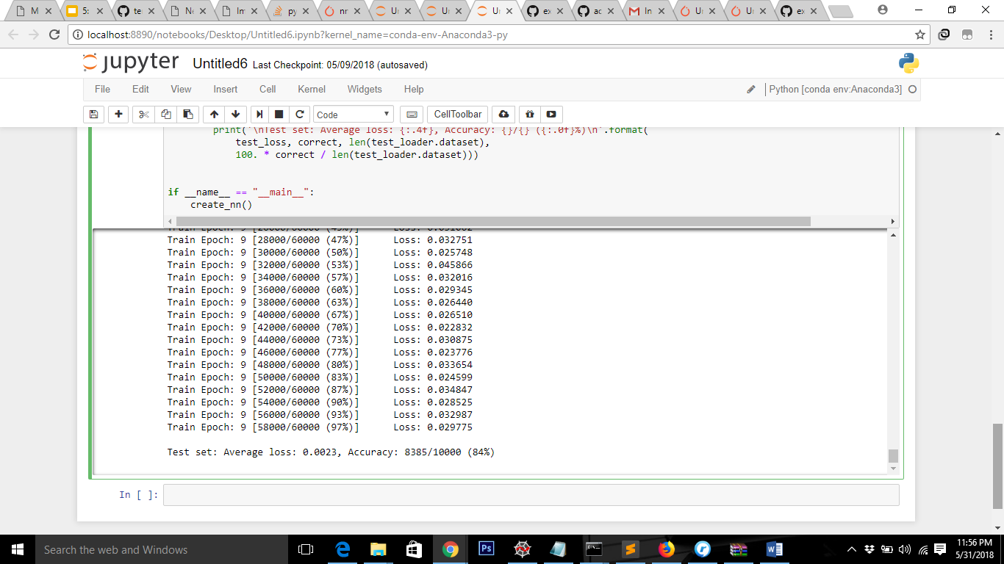

Accuracy – 84%

Changing **epoch count = 5 And**

def __init__(self):

super(Net, self).__init__()

**self.fc1 = nn.Linear(28 * 28, 200)**

**self.fc2 = nn.Linear(200, 10)**

def forward(self, x):

**x = F.relu(self.fc1(x))**

#x = F.relu(self.fc2(x))

**x = self.fc2(x)**

return F.log_softmax(x)

Accuracy= 87% (After epoch 0- 82% epoch1- 85% epoch2- 86% epoch3 – 85 % epoch 4-87%)

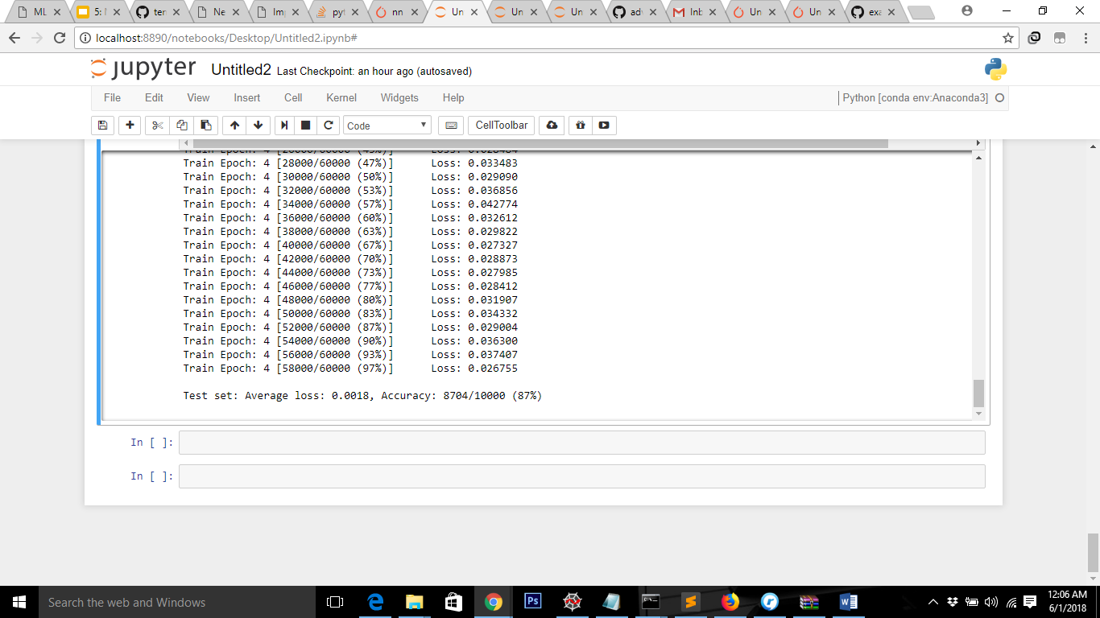

**create_nn(batch_size=200, learning_rate=0.001, epochs=5,**

**log_interval=5): Hyperparameters change**

ACCURACY : 82 %

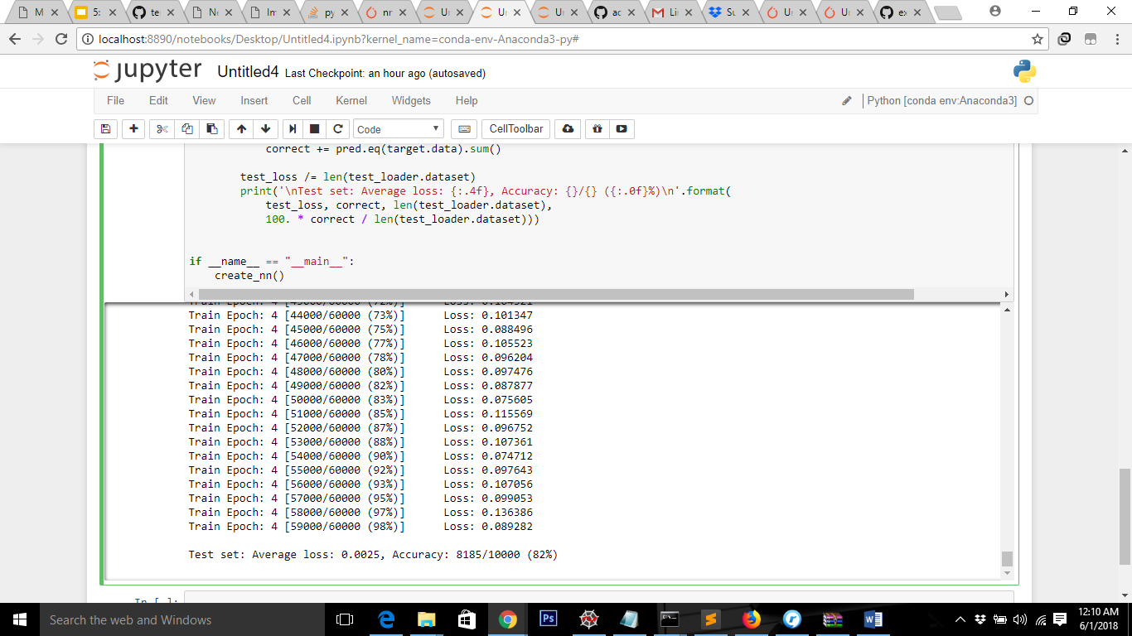

**WELL did both experimentally also similar results**

optimizer = optim.SGD(net.parameters(), lr=learning_rate, momentum=0.9)

optimizer = optim.Adam(net.parameters(), lr=learning_rate)